

#include <iostream>

using namespace std;

int main()

{

string str1,str2;

try{

cin>>str1>>str2;

int count, n=str1.size();

if(cin){

for(int i=0;i<n;i++){

if((str1[i]>=48 && str1[i]<=57) || (str2[i]>=48&&str2[i]<=57) )

throw 0;

if(str1[i]==str2[i])

count++;

}

if(count!=n)

cout<<str1<<" is not "<<str2;

else

cout<<str1<<" is "<<str2;

}

}

catch (int i){

cout<<"Inappropriate Input";

}

return 0;

}



#include <bits/stdc++.h>

#include <string.h>

using namespace std;

int main()

{

int k;

try{

cin>>k;

if(cin)

cout<<fixed<<setprecision(0)<<tgamma(k+1);

else

throw "e";

}

catch (int i){

}

catch (const char \*exp){

cout<<"Input should be a Integer";

}

return 0;

}



#include <iostream>

using namespace std;

int main()

{

int n,m;

try{

cin>>n;

cin>>m;

if(cin){

cout<<n-1+(1+2\*(n-1))\*(m-1);

}

else

throw 0;

}

catch(int griddimensions)

{

cout<<"Invalid Grid Dimensions";

}

return 0;

}



#include<bits/stdc++.h>

using namespace std;

int main()

{

float hour,salaryperday;

try{

cin>>hour;

cin>>salaryperday;

if(cin){

cout<<fixed<<setprecision(2)<<hour\*salaryperday;

}

else

throw 0;

}

catch(int workstatus)

{

cout<<"Insufficient Work Information";

}

return 0;

}



#include <iostream>

using namespace std;

int main()

{

int donuts,milk;

try{

cin>>donuts;

cin>>milk;

if(milk==0)

throw donuts;

else

cout<<"You have "<<(float)donuts/milk<<" donuts for each glass of milk";

}

catch(int e){

cout<<e<<" donuts and No Milk\nGo buy some milk";

}

return 0;

}



#include <iostream>

#include <math.h>

using namespace std;

int main()

{

int a;

try {

cin>>a;

if (a>0 && a<=100)

cout<<"Valid Mark";

else

throw "e";

}

catch(const char\* t){

cout<<"Invalid Mark";

}

}

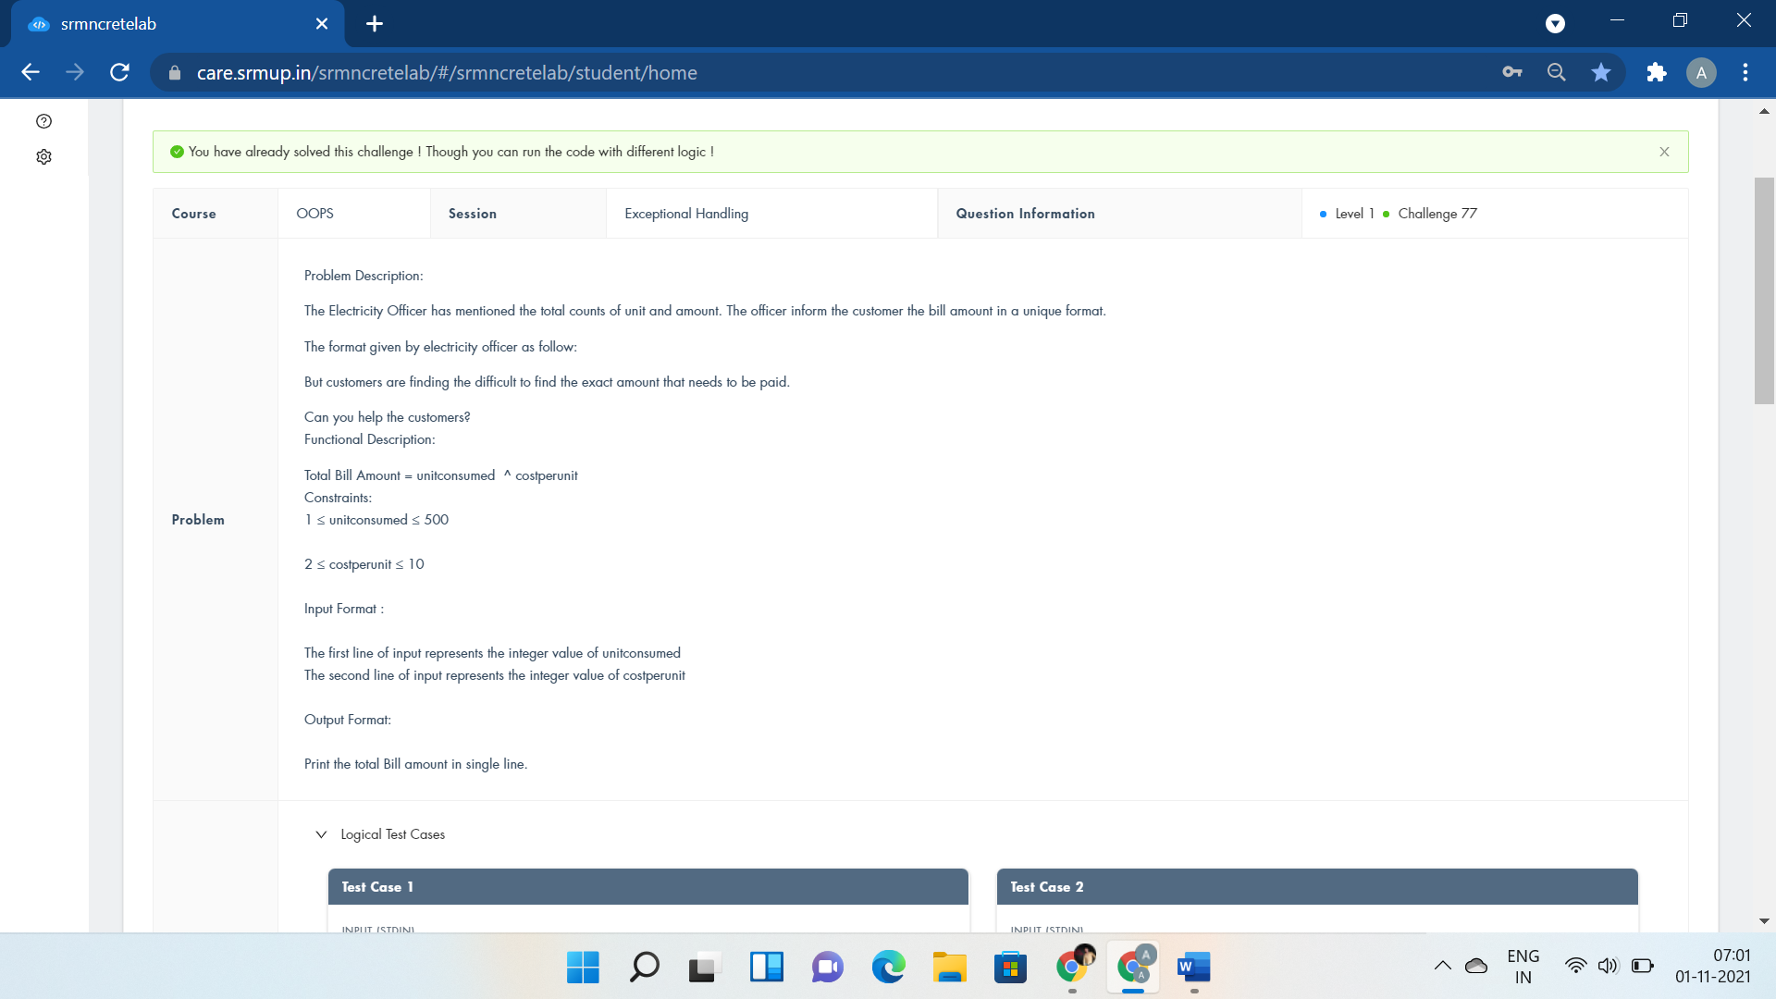

#include <bits/stdc++.h>

using namespace std;

int main()

{

int unitconsumed,costperunit;

try{

cin>>unitconsumed;

cin>>costperunit;

long int res;

res=pow(unitconsumed,costperunit);

if(cin){

cout<<res;

}

else

throw 0;

}

catch(int unit){

cout<<"Incomplete Data";

}

return 0;

}

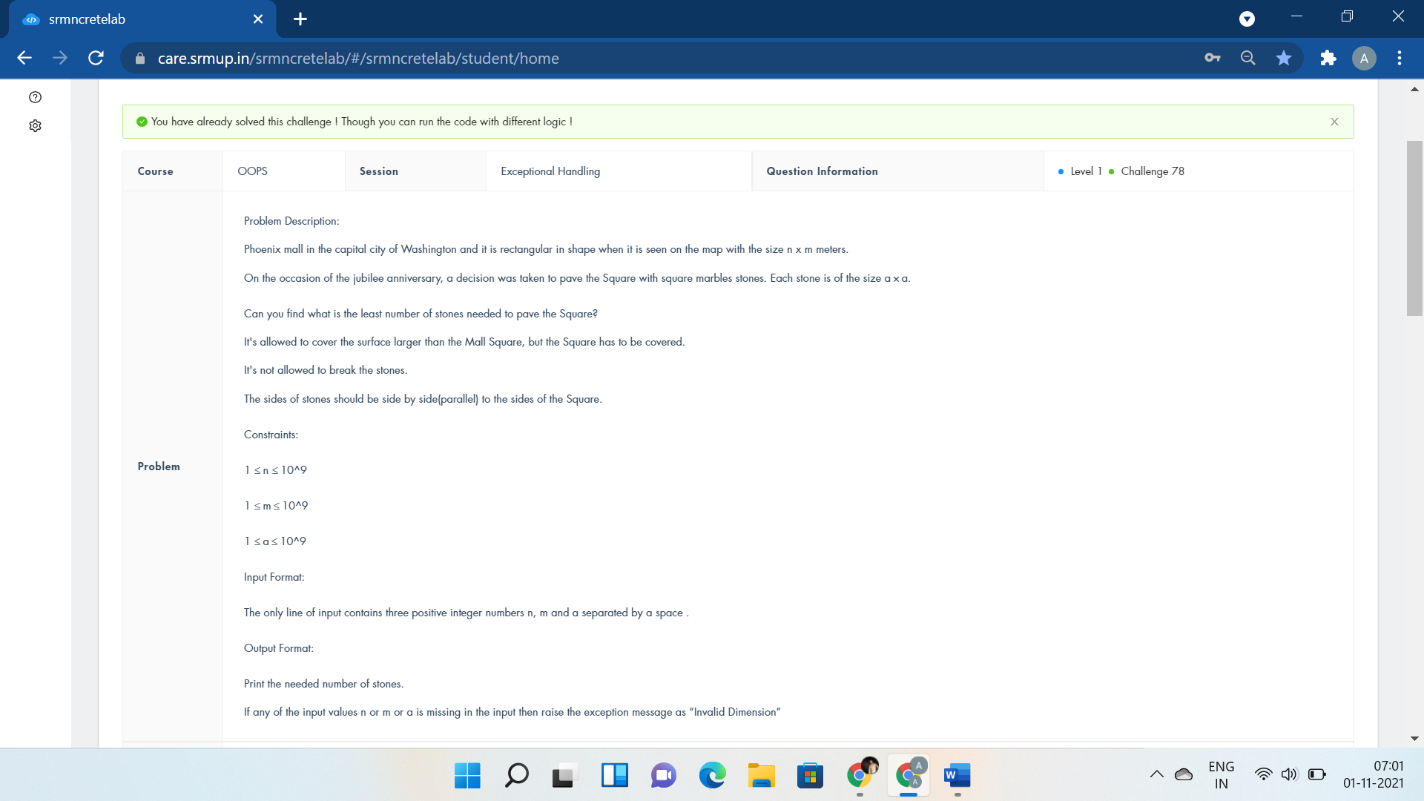

#include <iostream>

using namespace std;

int main()

{

int n,m,a;

try{

cin>>n>>m>>a;

if(cin){

cout<<((n+a-1)/a)\*((m+a-1)/a);

}

else

throw 0;

}

catch(int dimension){

cout<<"Invalid Dimension";

}

return 0;

}



#include<bits/stdc++.h>

#define f(i,a,n) for(i=a;i<n;i++)

using namespace std;

int main(){

int t,i,j;

cin>>t;

string str;

f(j,0,t){

f(i,0,2){

try{

cin>>str[i];

if(isalpha(str[i]))

cout<<str[i]<<" is alphabetic"<<endl;

else

throw str[i];

}

catch (char f){

cout<<f<<" is not alphabetic"<<endl;

}

}

}

}

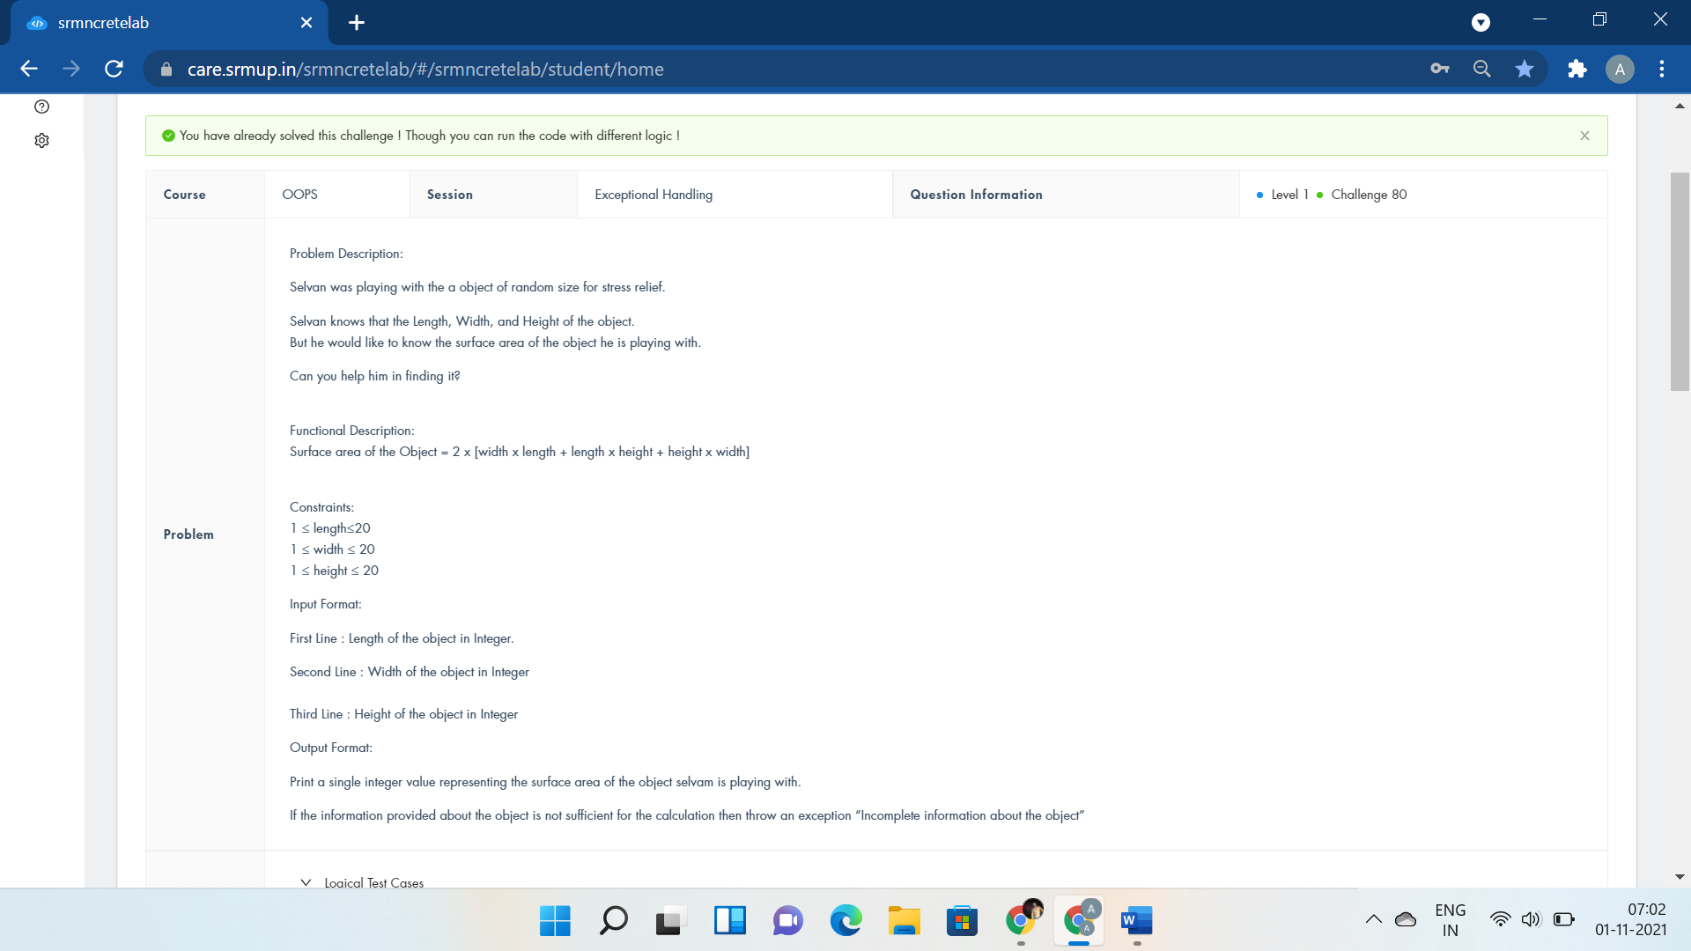

#include <iostream>

using namespace std;

int main()

{

int a,b,c;

try{

cin>>a>>b>>c;

if(cin){

cout<<2\*(a\*b+b\*c+c\*a);

}

else

throw 0;

}

catch(int objectinfo){

cout<<"Incomplete information about the object";

}

return 0;

}